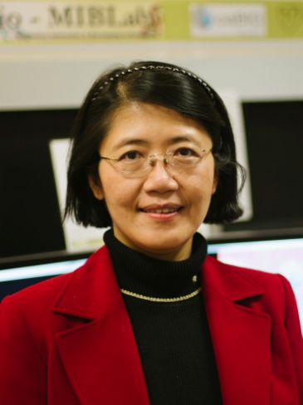

May Dongmei Wang, Ph.D.

Georgia Institute of Technology and Emory University
UA Whitaker Bldg. Suite 4106, 313 Ferst Dr., Atlanta, GA 30332-0535, USA
Email: maywang@bme.gatech.edu

Bio-Sketch
Dr. May Dongmei Wang is a full professor in the Joint Biomedical Engineering Department of Georgia Tech and Emory University, a Georgia Cancer Coalition Scholar, Georgia Tech Petit Institute Faculty Fellow, Director of Biomedical Big Data Initiative, a Kavli Fellow, and a Fellow of the American Institute for Biological and Medical Engineering (AIMBE). She earned BEng from Tsinghua University China, MSs, and PhD from Georgia Institute of Technology. Her research is in Biomedical Big Data Analytics with a focus on Biomedical and Health Informatics (BHI) for predictive, personalized, and precision health (pHealth). In FDA-organized MAQC international consortium, she led the comprehensive RNA-Seq data analysis pipeline study.
Dr. Wang published over 200 peer-reviewed conference and journal articles in referred journals (e.g. Briefings in Bioinformatics, BMC Bioinformatics, IEEE/ACM Transactions on Computational Biology and Bioinformatics, Journal of American Medical Informatics Association, Journal of Biomedical and Health Informatics-JBHI, Journal of Pathology Informatics, Proceedings of National Academy of Sciences-PNAS, Annual Review of Medicine, Nature Protocols, Circulation Genetics, IEEE Trans. on Biomedical Engineering-TBME, Annual Review of Biomedical Engineering etc.) and conference proceedings, and delivered more than 200 invited and keynote lectures. She received Outstanding Faculty Mentor Award for Undergraduate Research at Georgia Tech, and a MilliPub Award (for a high-impact paper that has been cited over 1,000 times) from Emory University.
Dr. Wang has served as an Emerging Area Editor for PNAS, Senior Editor for JBHI, an Associate Editor for TBME, and a panelist in NIH, and NSF review panels. She has helped organize ACM Bioinformatics, Computational Biology, and Health Informatics Conferences and IEEE International Conference on Biomedical and Health Informatics. Dr. Wang is elected as the Vice Chair for 2018 Gordon Research Conference (GRC) on Advanced Health Informatics, and has served in IEEE Big Data Initiative (BDI) Steering Committee.
Dr. Wang is Georgia Tech Biomedical Informatics Program Co-Director in Atlanta Clinical and Translational Science Institute (ACTSI), and Co-Director of Georgia-Tech Center of Bio-Imaging Mass Spectrometry. Her research has been supported by NIH, NSF, CDC, Georgia Research Alliance, Georgia Cancer Coalition, Emory-Georgia Tech Cancer Nanotechnology Center, Children’s Health Care of Atlanta, Atlanta Clinical and Translational Science Institute (ACTSI), and industrial partners such as Microsoft Research and HP.

